**A**

**Project Report**

**On**

**Bus Reservation System**

**Prepared By:**

**Tarun Adavani (16CE002)**

**Jayesh Bhutiya(16CE010)**

**Shlok Kakkad(16CE036)**

**Under the guidance of**

Prof. HardikMandora

Assistant Professor

**Submitted to**

Charotar University of Science & Technology Degree of Bachelor of Technology

Charotar University of Science and Technology

for Partial Fulfillment of the Requirements for the

3rd Semester Software Group Project-I (CE244)

**Submitted at**



**U. & P. U PATEL DEPARTMENT OF**

**COMPUTER ENGINEERING**

**Chandubhai S. Patel Institute of Technology**

**At: Changa, Dist: Anand – 388421**

**November-December 2015**



**CERTIFICATE**

This is to certify that the report entitled “**Bus ReservationSystem**” is a bonafied

work carried out by **TarunAdvani (16CE002), JayeshBhutiya (16CE010),**

**Shlok Kakkad (16CE036)** under the guidance and supervision of

**Prof. HardikMandora**for the subject **Software Group Project-I** (CE244) of 3rdSemester of Bachelor of Technology in **U & P U. Patel Department of Computer Engineering** at Faculty of Technology & Engineering – CHARUSAT, Gujarat.

To the best of my knowledge and belief, this work embodies the work of candidate himself, has duly been completed, and fulfills the requirement of the ordinance relating to the B.Tech. Degree of the University and is up to the standard in respect of content, presentation and language for being referred to the examiner.

|  |  |
| --- | --- |
| Prof. HardikMandora  Assistant professor  U & P U. Patel Department of Computer Engineering,  CSPIT, Changa, Gujarat. |  |
| Dr.(Prof.)Amit Ganatra Head,  U & P U. Patel Department of Computer Engineering,CSPIT,  Dean,  Faculty of Technology & Engineering,  CHARUSAT, Changa, Gujarat. | |

**Chandubhai S. Patel Institute of Technology**

At:Changa, Ta. Petlad, Dist. Anand, PIN: 388 421.Gujarat

**Abstract**

We hereby have the utmost privilege to thank our Software Group Project teachers **Prof. HardikMandora**for their support and guidance. We would also like to thank to **Mr. A.D. Patel**, the Principal and **Mr. Amit Ganatra**, the Dean for giving us this opportunity topresent this project. We would also like to thank our parents and my team for supporting and helping us to give my ideas, efforts in this project.

**Acknowledgement**

Our Bus Travel Facility is provides Online Bus ticket Reservation System. In our System we can provides different types of buses categories like Express, Volvo, AC or Non AC etc .In our system we can manage all types of Passenger data & bus data. All details that is related to Traveling like fare details,Seat availability, details of Booking, bus details, seating arrangements, inquiry etc.   
  
In our system we can provide the features to the passenger like the passenger could choose the available seats own itself, that is not provided by any other Agency. Our system also provide the facility like the Bus Boarding and the admin has facility to send Email & SMS.

**INDEX**

**Table of Contents**

Abstract……………………………………………………….…………………….………..3

Acknowledgement………………………………………….……………………………..…4

**Chapter 1 Introduction**……………………………………….………….......................….6

1.1 Project Summary………………………………………………………....……………………..6

1.2 Purpose……………………………………………………………….………………….……...6

1.3 Scope………………………………………………………………….….……………………...6

1.4 Objective……………………………………………………………….…..…….……………..6

**Chapter 2 Project Management**…………………………………..……………………….7

2.1 Project Planning ...........................................................................................................................7

2.1.1 Project effort and Time………………………………………..……………………...7

2.1.2 Roles and Responsibilities..............................................................................................7

**Chapter 3 Systems Requirements Study**.......................................……........................…..8

3.1 User Characteristics……………………………………………………….………………….…8

3.2 Hardware Requirements……………………………………………………...........................…8

3.3 Software Requirements………………………………………………………............................8

**Chapter 4 System Analysis**………………………………………………………………...9

4.1 Study of Current Analysis……………………………………………….…..............................9

4.2 Proposed System ……………………………………………………………………………...9

**Chapter 5 Major Funcationality** ……………………………………………………………...10

**Chapter 6 Screenshots**……………………………………………………………….…...11

6.1 Flow Chart…………………………………………………………………………………….12

**Chapter 7Limitations and Future Enhancements**..................….....................................13

**Chapter 8REFERENCES** ……………………………………………………………….14

**Introduction**

**Chapter 1: INTRODUCTION**

**1.1 Project Summary**

This project is basically for users i.e. Customers. This project focuses on managing the criteria of the customer to book tickets at utmost ease and with precise bus timings and routes.

* 1. **Purpose**

Purpose of this project is to replace the existing system of Bus Ticket Reservation.

**1.3 Scope**

This project will be helpful for customers to book tickets at utmost ease and with precise bus routes and timings so that they can travel without worries.

* 1. **Objective**

Objective of this project is that we wanted to expand our knowledge of JAVA and we also wanted to expand our knowledge about the present system.

**Project Management**

**Chapter 2: PROJECT MANAGEMENT**

**2.1 Project Planning**

**2.1.1 Project Effort and Time**

Every member of the team gave about 3 hours per week to make this project.

|  |  |
| --- | --- |
| TarunAdvani | 2 hours - Gathering the Infromation  1 hour - Analysis |
| JayeshBhutiya | 2 hours –Learning Java Concepts  1 hour - Implementation |
| Shlok Kakkad | 2 hours –Learning Java Concepts  1 hour - Implementation |

**2.1.2 Roles and Responsibilities**

|  |  |
| --- | --- |
| TarunAdvani | Information Gathering and Analysis |
| JayeshBhutiya | Coding |
| Shlok Kakkad | Coding and Testing |

**Systems Requirements Study**

**Chapter 3: SYSTEMS REQUIREMENTS STUDY**

**3.1 User Characteristics**

As we still have not created the website user should have some knowledge about java so he or she could use it.

**3.2 Hardware Requirements**

* Laptop or PC
* Ram 2 GB or Above

**3.3 Software Requirements**

**Software:-**

* JAVA SE 8

**Environment of Modification :-**

* Net beans 8.0.2
* Eclipse Neon 4.6

**System Analysis**

**Chapter 4: SYSTEM ANALYSIS**

**4.1 Study of Current System**

* Existing system is totally on book and thus a great amount of manual work has to be done. The amount of manual work increases exponentially with increase in services.
* Needs a lot of working staff and extra attention on all the records.
* In existing system, there are various problems like keeping records of items, seats available, prices of per/seat and fixing bill generation on each bill.
* Finding out details regarding any information is very difficult, as the user has to go through all the books manually.
* Major problem was lack of security.

**4.2 Proposed System**

* The system is very simple in design and to implement. The system requires very low system resources and the system will work in almost all configurations. It has got following features:
* Needs a lot of working staff and extra attention on all the records.
* Ensure data accuracy.
* Records are efficiently maintained by DBMS.
* DBMS also provides security for the information.
* Any person across the world, having internet can access this service.
* Availability of seats can be enquired very easily.
* Passengers can also cancel their tickets easily.
* Minimum time needed for the various processing
* Better Service
* Minimum time required
* This would help the corporation prepare and organize its schedules more efficiently on the basis of traffic demand.

**MAJOR FUNCTIONALITY**

**Chapter 5: Major Functionality**

Our Project held the following functionality and by that passenger can easily book the ticket without getting confused.

* + Destination
    - PASSENGER
    - Passenger ID
  + Username
    - Password
    - Name
    - Mobile number
  + E-mail
  + Constraints: Username should be unique

**Chapter 6: SCREENSHOTS**

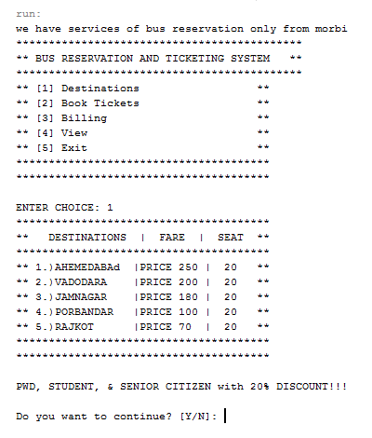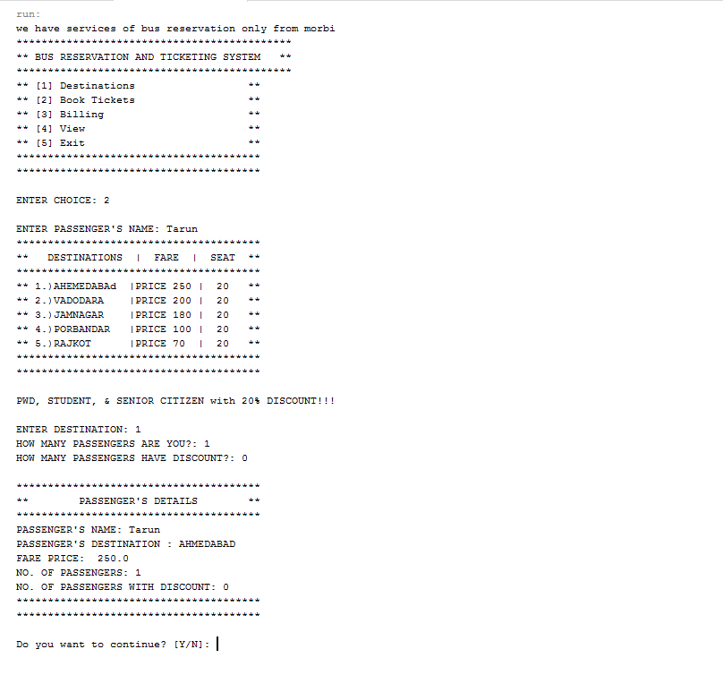

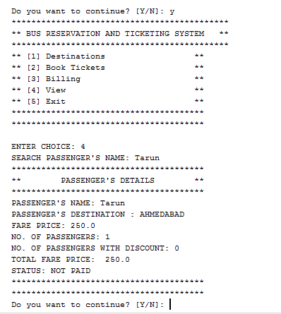

 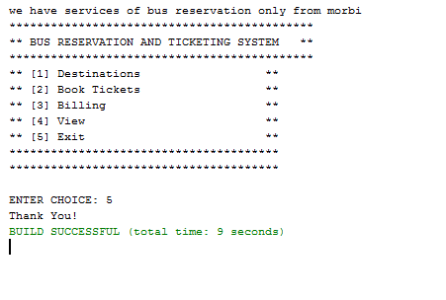

**6.1 FLOW CHART :-**

N

Invalid choice

Continue

nnot

5 or not

nnot

3 or not

nnot

2 or not

1 or not

nnot

4 or not

nnot

Destinations

N

End

Passenger’s Details

View

Billing

Passenger’s information

Book tickets

Y

Y

Y

N

N

N

N

Enter choice

Start

**LIMITATIONS AND FUTURE ENHANCEMENTS**

**Chapter 7: LIMITATIONS AND FUTURE ENHANCEMENTS**

* The limitations of our project mainly is that it has not yet been fully completed as we have not inserted payment gateways and we do not have a security to save the database of the user.
* We would like to insert payment gateways.
* We would also like to make a proper website for our project.

**REFERENCES**

**Chapter 8:REFERENCES**

1.<https://www.scribd.com/mobile/doc/35883362/Online-Bus-Reservation-A-Project-Report>

2.<http://googleweblight.com/i?u=http://shivajivarma.com/project/bus-reservation-system/&grqid=xfsHBofB&hl=en-IN>

3.<http://bookmarksland.net/downloads/bus_reservation_system_project_documentation.pdf>

4.<http://googleweblight.com/i?u=http://www.angleritech.com/case_studies/online-bus-booking-system/&grqid=KDVbjX34&hl=en-IN>

5.<https://googleweblight.com/i?u=https://www.codeproject.com/Questions/607451/onlineplusbusplusbookingpluswebplusapplication&grqid=1aLxmajb&hl=en-IN>